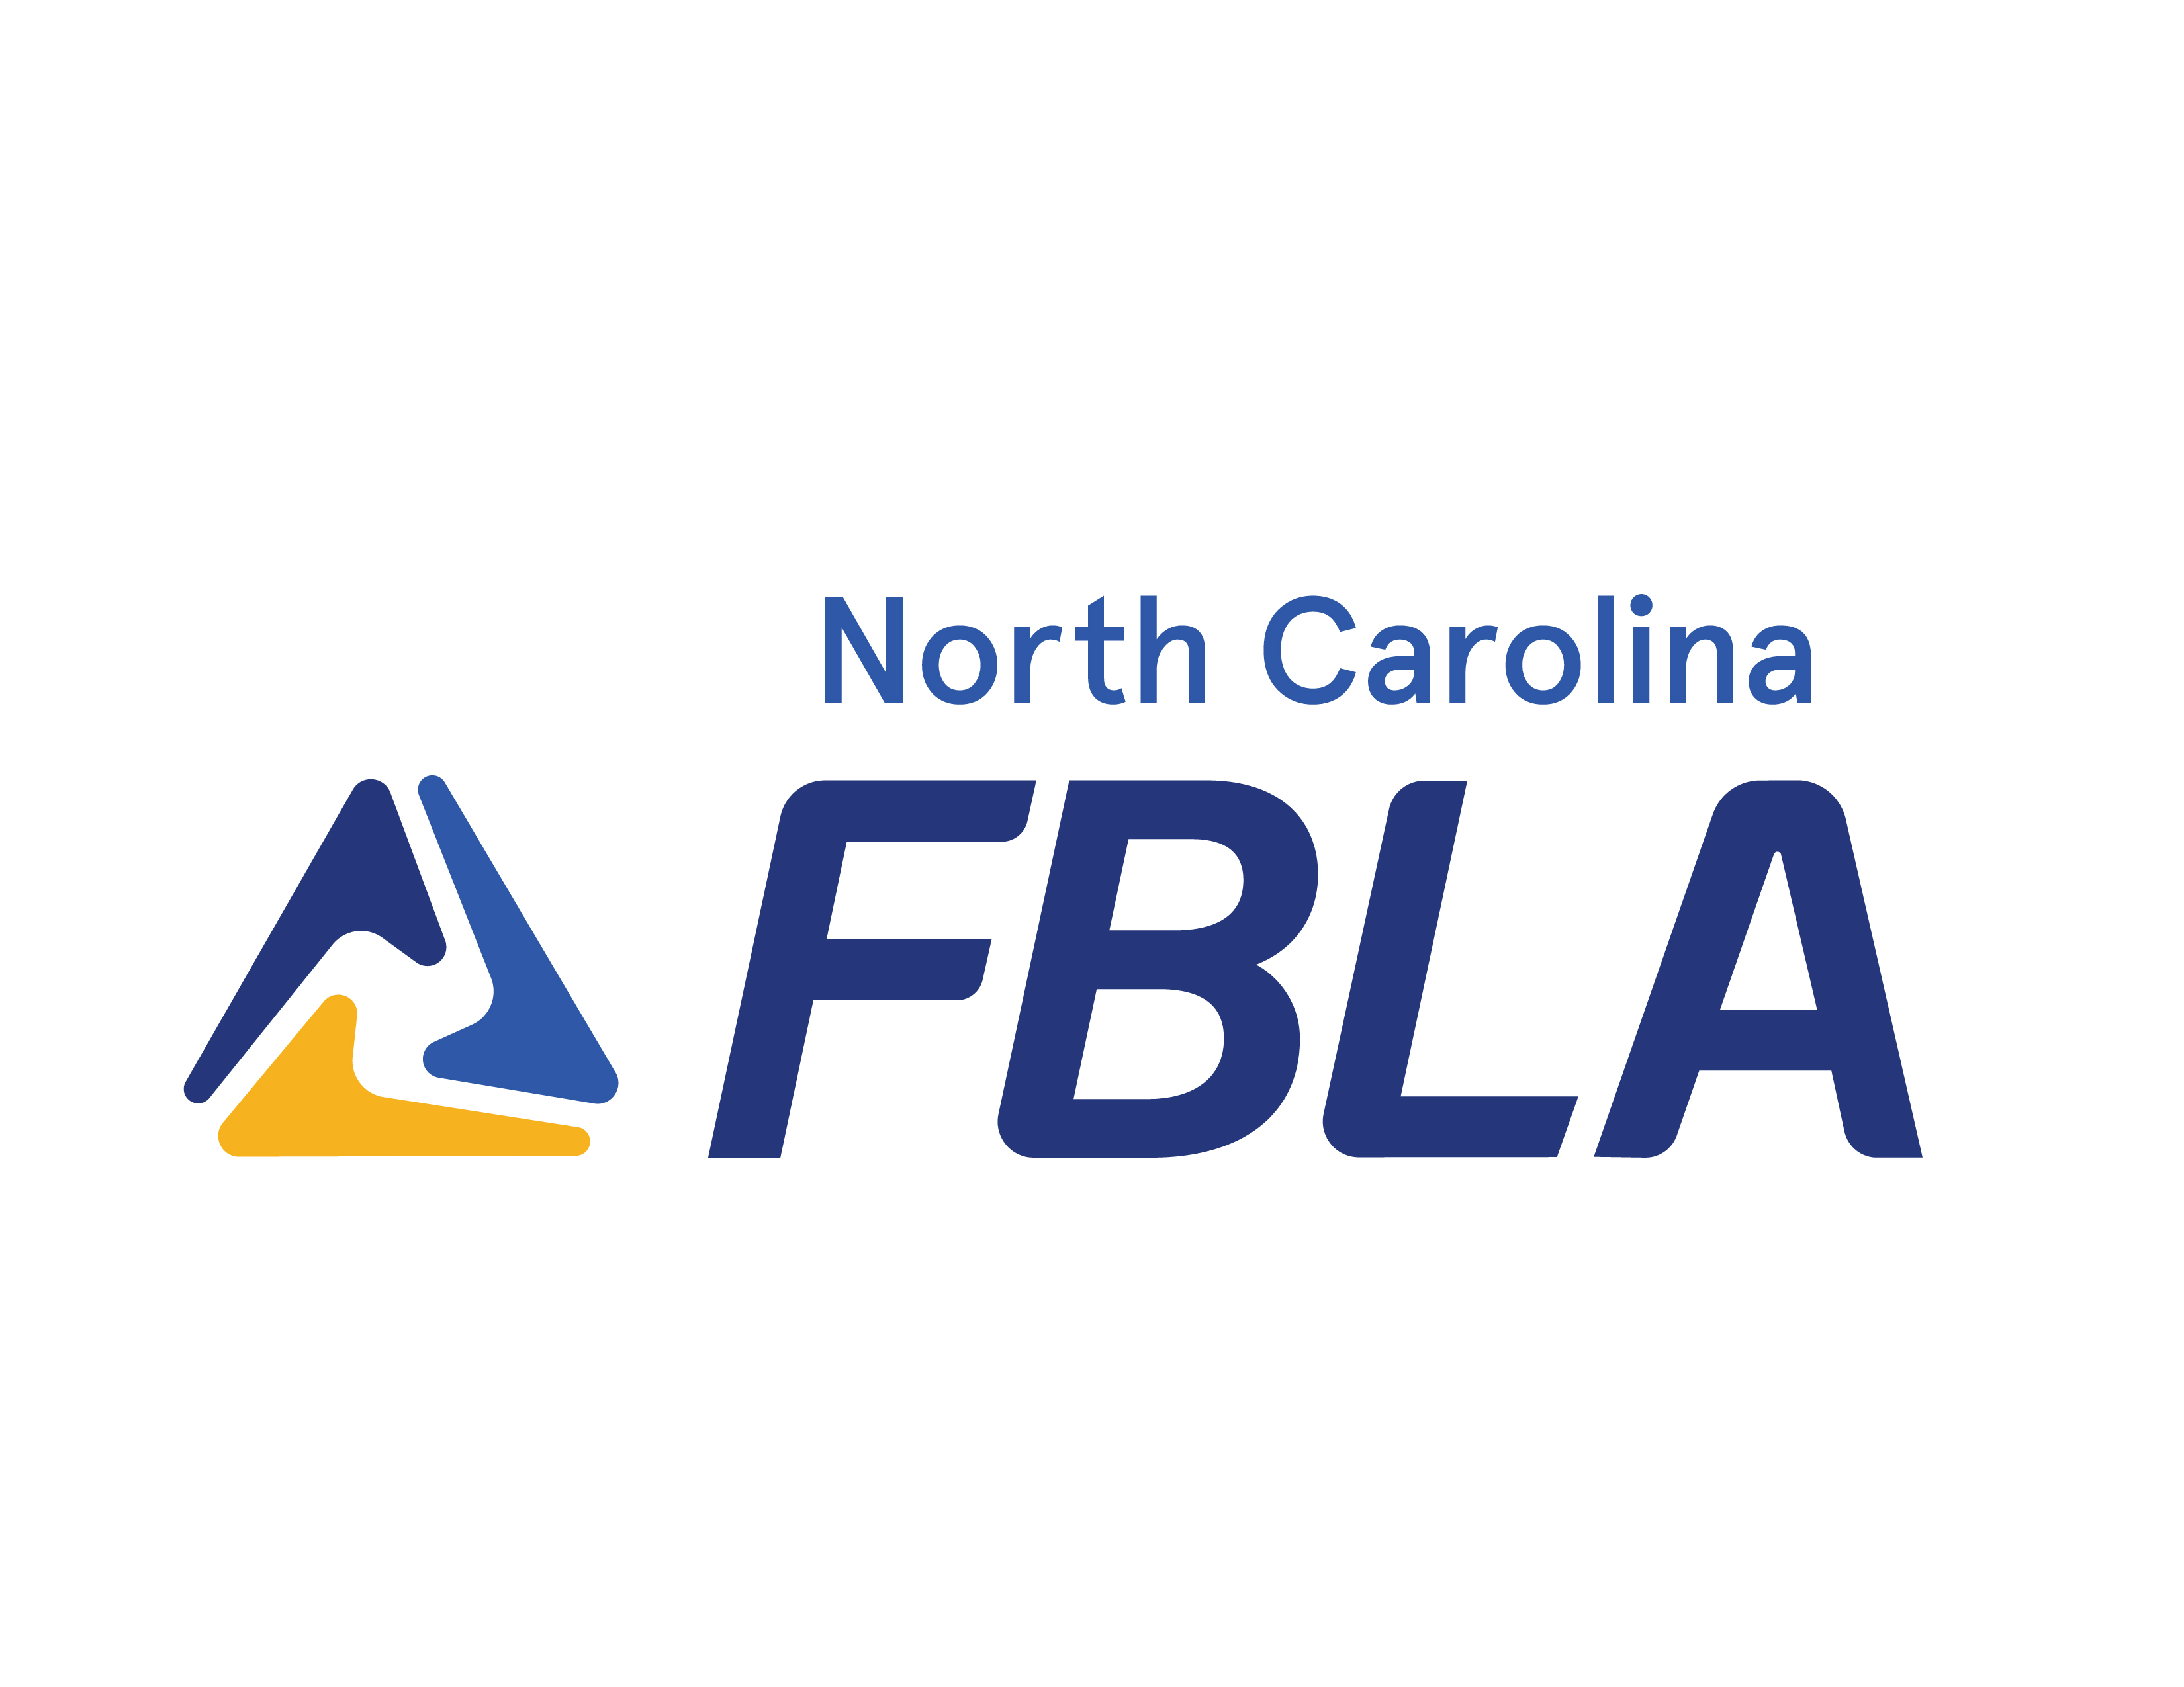
Chapter Management Handbook

Updated August 2024
NC Department of Public Instruction
Catherine Truitt
State Superintendent of Public Instruction

Trey Michael
Director, Career and Technical Education

Elizabeth Matthews
Business, Finance, and Marketing Education Consultant

Ashley Matthews-Smith
Middle Grades Education Consultant

North Carolina FBLA
Ashleigh Wagoner
North Carolina FBLA State Adviser

NCFBLA Board of Directors
Central | Laura Corraro
Eastern | Kurt Garner
Northwest | Kathryn Cogdell
Southeast | Kimberly Hackett
Southwest | vacant
Triad | Jennifer Adcock
Triangle East | Carol York
Western | Michelle Brooks
Middle School | Julie West
Professional Division | Michael McKay

NCFBLA State Officers
Central | Caroline Santo
Eastern | Wright Collins
Northwest | Shirina Baskaran
Southeast | Kennth Van Wy
Southwest | Sahasra Bangaru
Triad | Om Patel
Triangle East | Vy Dang
Western | Nadia Owel
Parliamentarian | Christopher Mancera-Gonzalez
President | Yasha Nagathan

Table of Contents
Table of Contents 3
Calendar of Activities 5
Membership 5
Membership Definition 5
Aligned currirulucm 5
Membership Dues 5
State/National Membership Registration 5
Dues Deadlines 6
2025-2025 THEME 6
State Key Contacts 7
Board Eligibility 7
Nomination for NCFBLA Executive Board 8
Regional Information 9
NCFBLA Regional Alignment 9
Regional Leadership Conferences 9
Competitive Event Eligibility 9
About Competitive Event Entry Forms 10
Registration Procedures for Regional Competitive Events 10
Home Site Testing 11
Code of Conduct 11
NC FBLA PERMISSION FORM 12
DELEGATE CODE OF CONDUCT 13
Business Person of the Year 15
National Information 16
National Leadership Conference (NLC) 16
National Fall Leadership Conference (NFLC) 16
Local Chapter News 16
National Resources 16
Conference Participants 17
Conference Registration 17
Competitive Events 18
Home Site Testing 18
Competitive Events with Eligibility Restrictions 19
James L. White Scholarship Contributions 19
State Officer Candidates 19
Adviser of the Year 20
VOTING DELEGATES 22
Voting Delegates 22
Adviser Responsibilities 22
Voting Delegate Responsibilities 22
James L. White Scholarship Fund 23
Local Chapter Contribution 23
100% Class Participation Award 24
Dress Code for State, Regional and National Leadership Conferences 25
North Carolina Professional Division 26
Professional Division Membership Application 27

Calendar of Activities
The calendar of activities is constantly being updated. It has been omitted from this manual to avoid any references to an outdated calendar. Please refer to the North Carolina FBLA website for the current calendar (www.ncfbla.org).

Membership

Membership Definition

Active membership in FBLA is available for middle and high school students who have a career interest in business.

Professional membership is automatic for local chapter advisers. Chapter advisers must be a faculty member at the school and must register in FBLA Connect.

Aligned currirulucm
The North Carolina Department of Public Instruction provides curriculum related to Business, Finance, & Marketing and Computer Science, Information Technology, & Technology Education at both the Middle and High School levels. Information for both curriculum areas can be found on the NCCTE Course Management System.
- Business, Finance, and Marketing
- Computer Science, IT, and Technology

Membership Dues

Local middle school and high school chapters must affiliate with both the state and national organizations in order to use the name FUTURE BUSINESS LEADERS OF AMERICA (FBLA). Membership information is available online at www.fbla.org/fbla-membership-dues/ .

MEMBERSHIP DUES REPORTING PROCEDURES FOR 2023-2024
DUES |  | FBLA High School |  | FBLA Middle Level
State Dues |  | $6.00 |  | $5.00
National Dues |  | $10.00 |  | $10.00
Total Dues per Member |  | $16.00 |  | $15.00
Advisers who have membership questions may email Lisa Smothers at lsmothers@fbla.org.

State/National Membership Registration
Please follow these procedures for submitting membership forms and checks. All membership forms must be completed online.

To activate or login into your account, go to: https://www.fbla.org/start-or-reactivate-a-chapter/.
- Print a copy of your invoice from your local chapter. Keep a copy for your records and send a copy with your payment for state and national dues. Your chapter membership is not activated until the membership roster and payment are received.
- Write one check to cover both state and national dues. Total state and national dues are $16.00 per member for high school members and $15.00 per member for middle school members. Local chapters must affiliate with both the state and national organizations to use the name Future Business Leaders of America (FBLA) and participate in competitive events.

Dues Deadlines
Dues MUST be paid by November 1 (receipt deadline) for your chapter and members to:
- Be placed on active mailing list.
- Qualify for the Gold Seal Award.
- Compete at regional competitive events.

STUDENTS MAY NOT COMPETE IN REGIONAL COMPETITIVE EVENTS UNLESS THEIR DUES ARE RECEIVED BY NOVEMBER 1.

Dues MUST be paid by January 10 (receipt deadline) for your chapter and members to participate in the State and National Leadership Conferences.

2025-2025 THEME
The national FBLA theme is Dare to Dream, Dare to Lead. Feel free to use this theme throughout the year on any printed material or as advertisement for local chapter activities, such as bulletin boards, programs, newsletters, etc.

The NC FBLA State theme is Guiding You to Success. Please feel free to use this theme throughout the year on any printed material or as advertisement for local chapter activities, such as bulletin boards, programs, newsletters, etc.

State Key Contacts

Executive Board: https://ncfbla.org/contacts/#executiveboard

State Officers: http://ncfbla.org/contacts/#officers

Regional Advisers: http://ncfbla.org/contacts/#regional

NC FBLA Executive Board

The NC FBLA Executive Board is composed of local chapter advisers from each of the eight FBLA regions in North Carolina. Each regional board representative is elected for a three-year term by the chapters located in their region.

Board members are elected to serve the local chapters in their respective regions. If you have suggestions or recommendations that you would like to have presented to the Board, contact the board representative from your region. Board members and their term of office are shown below.

Executive Board: http://ncfbla.org/contacts/#executiveboard

Board Eligibility

Duties and responsibilities of board members are listed in Article V, Sections 3 and 4 of the NC FBLA Bylaws. Please use the Nomination for Executive Board Form to nominate an adviser from your region in the year the term for the board member from your region expires. All nominations must be returned by the deadline listed in the Calendar of Activities. Following the receipt of nominations, local chapters will be notified of voting procedures.

In addition to being willing to promote and uphold the high ideals of NC FBLA, board members must also meet the following eligibility requirements:

- Served as an adviser or co-adviser of an active FBLA chapter for least three years.

- Attended and participated in at least three leadership conferences at the state, regional, or national levels.

- Attended and participated in NC FBLA regional meetings.

Nomination for NCFBLA Executive Board

CHECK YOUR REGION
Central Eastern Northwest Southeast
Southwest Triad Triangle East Western

(Please nominate only one adviser from your region.)
Nominee Name
School Name
School Address
School Email
School Phone Number ( )
# of Years spent as FBLA Adviser
I have checked with this individual to make sure he/she agrees to run for this Board position and that he/she meets the qualifications outlined in the State Bylaws.
Yes No
Nominated by:
Please explain in about 500 words why you are nominating this person.

School
Date

Please email this form by November 1 to the State Adviser at NCFBLAStateAdviser@gmail.com.

Regional Information

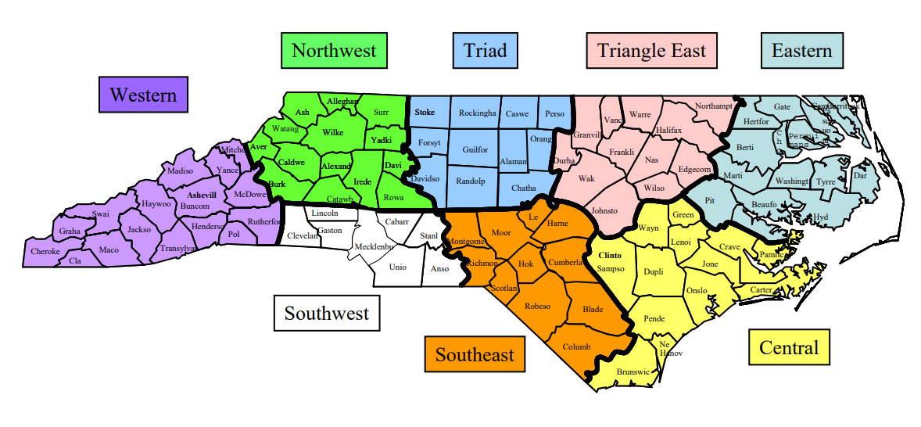
NCFBLA Regional Alignment

Regional Leadership Conferences

A Regional Leadership Conference is scheduled for each NCFBLA region. Each local chapter will receive registration information/materials from the vice president/board member of your region.

Local chapter advisers who have not received conference registration materials at least five weeks prior to the scheduled conference date should contact their regional adviser. Email addresses for regional advisers are listed under the ‘Contact’ tab at www.ncfbla.org.

The success of these regional events depends upon everyone's cooperation. It is possible that a chapter will be disqualified from participation if they fail to meet the deadline date for submitting registration materials and entry forms by the date set from their regional advisers. Your NC FBLA Executive Board and regional advisers’ contact information is located under the ‘Contact’ tab at www.ncfbla.org.

Competitive Event Eligibility
Student members participating in regional and state competitions must be ACTIVE FBLA members. Active membership means that a high school or middle level student has a career interest in business and has paid both state and national dues. State dues must have been postmarked by November 1 for students to be eligible for regional competition.

About Competitive Event Entry Forms

Regional competitive events will be conducted according to the event guidelines in the NC FBLA Competitive Events Program. Students who do not adhere to the guidelines will be disqualified. If you need a copy of the guidelines check the website http://ncfbla.org/documents

The first, second, third and fourth-place high school and first, second, third and fourth- place middle level winners from each region will advance to competition at the State Leadership Conference. The winners of the NCBEA Outstanding Student Service Award and Regional Businessperson of the Year will be recognized at the Regional Competitive Events and the State Leadership Conferences.

Registration Procedures for Regional Competitive Events

You will receive detailed information regarding the competitive events from your respective regional vice president and regional adviser. Please return the registration information and required fees to your regional officer/adviser by the stipulated deadline.

Local chapter advisers who have not received conference registration materials at least five weeks prior to the scheduled conference date should contact their regional adviser.

Home Site Testing

NC FBLA uses home site testing to administer Computer Applications, Spreadsheet Applications, and Word Processing. Local chapters are permitted to conduct the production portion of these events at the student's home school. This allows students a better opportunity to demonstrate proficiency on familiar equipment and eliminates the difficulty schools have in bringing equipment to conferences. Students participating in home site events must be registered for the Regional Leadership Conference in their region by the designated deadline.

Local chapters must identify an impartial test administrator (not a BFM or CSITT teacher) to administer the test as the Proctor. A Test Administrator Identification form will be provided by the regional adviser/regional board member with other RLC documents at the time of registration. The form is to be emailed to the regional adviser with your registration materials by the indicated deadline date. Upon receipt of the identification form, the regional adviser will send the test, administrator release form, guidelines, script, and return envelope to the test administrator you have identified. Tests are confidential and cannot be emailed until a Home Site Test Administrator Form has been keyed and submitted.

After the test is completed, any printed materials (test, administrator release form, guidelines, script, and student's test documents) must be shredded. Any electronic documents saved during testing must be deleted from the computer. Home site tests are confidential and ARE NOT TO BE COPIED.

Code of Conduct
Please bring signed, completed physical copies of the included NCFBLA Permission Form and any permission forms that your school or district requires for your students. These should accompany you and your students during all NCFBLA events.

Also included is the DELEGATE CODE OF CONDUCT. For all NCFBLA Leadership Conferences they should be printed, signed by all students and advisers, and brought along at all times.

NC FBLA PERMISSION FORM

Student Full Name:
Activity:
City/State:
Departure (Date/Time):
Return (Date/Time):

My child understands that they will be expected to attend all conference activities and to always conduct themselves in a proper, businesslike manner. Proper manners also includes neither possession of nor use of intoxicating beverages or drugs. My child and I understand and accept the rules and regulations governing this conference or meeting and any violation of the rules or the code of conduct may result in dismissal from the event.

It is understood that my child will be chaperoned while attending this event and that normal precautions will be taken in the interest of their safety and well-being. I grant permission for medical aid should an emergency occur.
Medical Insurance Provider: #
Transportation will be one or a combination of those listed below (please check).
My student has my permission and will be traveling with (parent, adviser, etc.) to and from the above named activity.
Airplane Bus Other (specify
Private auto. My child has my permission to drive to and from the above named activity.
My student has my permission to carry others as passengers in his/her vehicle.
Delegate's Signature__________________________________________________
Parents' Signature_____________________________________________________
Parents’ Full Name ___________________________________________________
Address Telephone( )

Advisers: Reproduce this form and have a signed copy in your possession for each student attending FBLA functions. Take this form with you to each function in case you need it. Also, make sure that students and parents are informed of conference rules and regulations.

NORTH CAROLINA FUTURE BUSINESS LEADERS OF AMERICA
REGIONAL & STATE CONFERENCES

DELEGATE CODE OF CONDUCT

It is a special privilege to attend an FBLA conference and it is the responsibility of all delegates to always conduct themselves in a proper, businesslike manner. All participating delegates are required to read this document and sign stating their understanding.

FBLA members have an excellent reputation. Your conduct at all FBLA functions should make a positive contribution to the reputation that has been established. Listed below are conduct rules for regional and state conferences.

All delegates shall behave in a courteous and respectful manner, refraining from language and actions that might bring discredit upon themselves, their school, or FBLA.

Conduct not conducive to an educational conference is prohibited. Such conduct includes, but is not limited to, actions disrupting a businesslike atmosphere, association with non-conference individuals or activities which endanger self or others.

Delegates shall keep their advisers informed of their activities and whereabouts. Accidents, injuries, or illnesses must be reported to the adviser immediately.

Curfews are listed in the conference programs. Curfew will be enforced by local and state advisers, professional division members and security personnel. Curfew is defined as being in your assigned room by the designated hour.

Alcoholic beverages and narcotics in any form shall never be in your possession at any time, under any circumstances. Use or possession of such substances may subject the delegate to criminal prosecution.

Conference delegates are guests of the hotel and convention center and must not deface or destroy property. Do not throw ANYTHING out of windows or over balconies, not even water. Any damages to property or furnishings in the hotel or convention center will be paid for by the individual or chapter responsible.

As a delegate to the any of the FBLA Leadership Conferences, permission is granted to make photographs, videotapes, broadcasts, and/or sound recordings, separately or in combination, available for reproduction for educational and promotional purposes by the State and National FBLA.

Advisers are responsible for the supervision of delegate conduct. Delegates who disregard the code of conduct will be subject to disciplinary action and can be sent home at their own expense. Parents will be notified.
“I fully understand the Delegate Code of Conduct and agree to comply with these guidelines. Furthermore, I am aware of the consequences that will result from violation of any of the guidelines.”

DELEGATE SIGNATURE | DATE
“I have read and fully understand the Delegate Code of Conduct and agree to help enforce these guidelines”

Adviser Signature Date

Adviser Name: School Name:

Business Person of the Year
NC FBLA STATE COMPETITIVE EVENTS ENTRY FORM
BUSINESSPERSON OF THE YEAR
Name of Businessperson

Occupation

Type of Business

Complete Business Address

Business Telephone

Home Telephone

Name of Nominator |  | Date:
School | Region
Complete School Address
School Address:

City, State Zip:

Adviser’s Signature | Adviser’s School FAX
Adviser’s School Phone | Adviser’s E-mail
Adviser’s Planning Time | Adviser’s Home Phone
Please return this form and the businessperson’s résumé to your Regional Board Member by November 1.

National Information
FBLA National Conferences

FBLA offers national meetings that promote leadership development. FBLA conferences are a great place to reach our audience face-to-face.

National Leadership Conference (NLC)
FBLA members have a competitive edge, as the best and brightest of FBLA convene to compete in leadership events, share their successes, and learn new ideas about shaping their career future through workshops and exhibits. This conference is considered the pinnacle of the FBLA experience, especially for those running for national office. FBLA has forged partnerships with industry leaders to underwrite competitive events and scholarships for students achieving national ranking.

Many of our state winners from SLC represent North Carolina and compete at NLC. Refer to www.fbla.org for current dates and location.

National Fall Leadership Conference (NFLC)

The FBLA National Fall Leadership Conference is an excellent opportunity for students to attend a national conference. FBLA members and advisers from many states in several regions will be participating at the conference. All active local chapters should receive registration materials directly from the national office. Most of the information about NFLC can be viewed from the home page tab for NFLC at the national website. Refer to the calendar of activities for location and dates. Information about the conference is also posted on the national website www.fbla.org.

Local Chapter News

Local chapters can make national headlines by submitting to the National office.
Submit your news and success stories to the FBLA National Center. Simply fill out this form and you may see your story in a national publication or highlighted at a national conference! A confirmation will be emailed to verify your submission. Please note that all submissions should summarize/report on a chapter or state activity which has already occurred (do not submit plans for an upcoming event). Submissions must be in English for publication consideration.

National Resources
For information regarding National Partnerships, Fundraising, Educational Programs, and more, please refer to the National Chapter Handbook. This can be found in the FBLA Connect system.

NC FBLA State Leadership Conference
The annual NC FBLA State Leadership Conference is an outstanding leadership experience for FBLA members. Information in this section is designed to enable your chapter to have an educational and enjoyable experience. Please read the information in this section carefully. Refer to the calendar of activities for dates and locations.

Conference Participants
Active local chapters that have paid dues by January 10 are permitted to participate in the State Leadership Conference. Delegates must hold active membership in FBLA. Each chapter member attending the conference is required to actively participate in conference activities. Active participation includes being a competitive event contestant, workshop participant, scholarship finalist, campaigning for state office, assisting in an officer candidate campaign, serving as a voting delegate, or involved in some other conference activity. Advisers are required to help manage and facilitate conference activities. It truly takes a village to execute a conference of this size and everyone’s cooperation is imperative.

Conference Registration
All persons (delegates, advisers, and guests) attending any of the conference activities must pay the registration fee. ALL REQUESTS FOR REFUNDS MUST BE MADE IN WRITING and must be sent via email to the State Adviser and the Regional Board Member. Full refunds are not given. Refunds for 50% of the registration will be mailed after the conference if the request is received by the designated date posted on the calendar. Substitutions are not allowed once registration is closed. ALL REGISTRATION IS COMPLETED ONLINE. No additional delegates will be permitted to register after the stated deadline. No on-site registration will be available. The conference registration fee is used to pay conference expenses, including:

- Conference materials
- Meeting Space Rental
- Audio/Video Production
- Keynote Fee
- Plaques/Awards
- Security Officers
- Printing
- Decorations
- Disc Jockeys & Entertainment
- Staging
- Adviser Materials

When completing the registration materials, please follow the directions on the web site and on the online Conference Registration Form. Please use a school check or money order. Do not send personal checks or cash.
Checks should be made payable to NC FBLA and mailed to:

NC FBLA
P. O. Box 693
Rolesville, NC 27571

The RECEIPT deadline for registration materials is listed in the Calendar of Activities.

Competitive Events
The most recent edition of the NC FBLA Competitive Events Program governs all competitive events. This Program is distributed to the NC FBLA Board of Directors and posted online as the board approves.

Advisers should be familiar with event guidelines and rating sheets. Make copies of the guidelines for your students for their respective events. Take note of any eligibility requirements and deadline dates.

A student may enter an individual event or team event AND a chapter event.
Please check the table located in the NC FBLA Competitive Events for middle grade or high school student events.

See the NC FBLA Competitive Events Program for a listing of all competitive events, recognition events, and the event guidelines.

Regional winners MUST RE-REGISTER for State Competition. Since all registration is completed online only the local advisor can register a student. The regional board members will submit a list of regional winners to the NC FBLA State Office for verification.

Home Site Testing

NC FBLA uses home site testing to administer:
- Computer Applications
- Spreadsheet Application
- Word Processing

All local chapters are permitted to conduct the production portion of the competition (Home Site test) at the student's home school. This allows students a better opportunity to demonstrate proficiency on familiar equipment and eliminates the difficulty schools have in bringing equipment to conferences.

Students competing in Computer Applications, Spreadsheet Application and Word Processing at the NC FBLA State Leadership Conference must be 1st, 2nd, 3rd. or 4th place regional winners. All home site testing event competitors must be registered for the SLC by the designated deadline.

Local chapters must identify an impartial test administrator (not a business teacher in the department) to administer the home site test and submit a Test Administrator Identification Form. This person will be required to sign and date a release form indicating that the test has been administered according to regulations and will be emailed along with other specific testing items.

Tests will not be emailed until the test administrator/proctor has been identified and the adviser has registered his/her students for SLC and submitted the correct email address on the online registration site.

After the test is completed, the test will be uploaded by the student per email instructions. All other documents required for the test will be destroyed by the proctor.

Competitive Events with Eligibility Restrictions
Please refer to the NC FBLA Competitive Events Program to see eligibility for each event.

James L. White Scholarship Contributions
We encourage local chapters to contribute to the James L. White Scholarship Program. Your chapter will earn points toward eligibility for a Gold Seal Chapter Award of Merit and the Helen Ragan Chapter of the Year. Please support this worthwhile scholarship for outstanding business students. Chapters contributing $25 or more will have their chapter listed in the conference program and will receive a James L. White ribbon. The deadline for submitting your contribution and receiving points for Gold Seal is listed in the calendar of activities. A form for scholarship contributions is included below.

State Officer Candidates

Local chapter advisers who observe leadership qualities and commitment in a chapter member should discuss with the member the possibility of applying to become a candidate for a state office position. Advisers should make students aware of the duties and responsibilities involved in serving as a state officer. The duties of each state officer are listed in the NC FBLA Bylaws and in the NC FBLA State Officer Guide.

A state office is not just a title to be held and enjoyed; but rather, it is a serious and time-consuming task requiring much sacrifice. There are also many rewards. Leadership development activities in which officers are involved may include State Officer Training, National Leadership Conference, National Fall Leadership Conference, CTE Summer Conference, NC FBLA Regional Conferences, and the State Leadership Conference.

An application and screening information are available in the State Officer Guide, available on the NC FBLA website, www.ncfbla.org. The postmark deadline for submitting officer application materials is listed on the Calendar of Activities.

Adviser of the Year

Nominations for Adviser of the Year may come from local chapter advisers, FBLA members and/or local school administrators. Nominations must be submitted by December 20. After receiving completed nomination forms for this event, the state office will contact nominees requesting additional information to be used by an impartial selection committee.

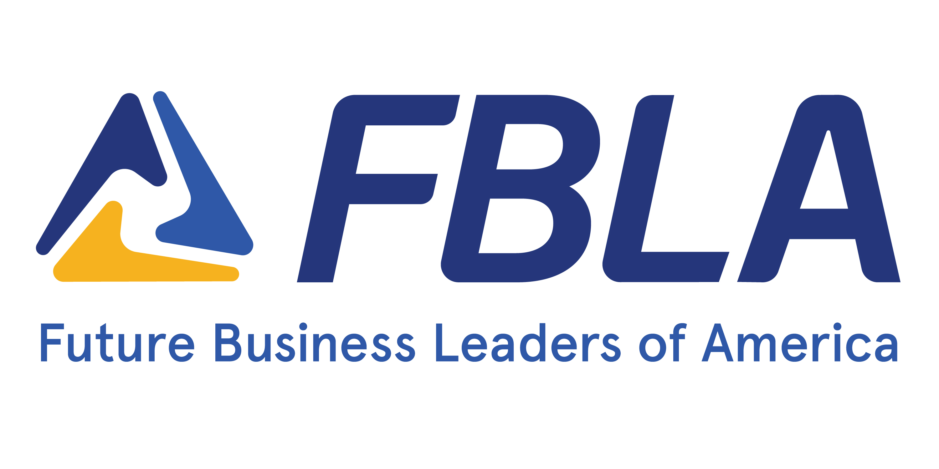

North Carolina FBLA
Adviser of the Year Nomination

Name of Adviser Nominee

School

Region

School Address:

City, State Zip

School Telephone

( )
Home/Cell Telephone
( )
Nominee’s e-mail

Name of Nominator

Nominator Email:

In about 500 words, please explain why this person deserves to be the Adviser of the Year:

Please return this form to the state office by the receipt deadline specified on the NC FBLA Calendar of Activities.
For Office Use Only

VOTING DELEGATES

Voting Delegates

Each active local chapter is entitled to send voting delegates from its active membership to the State Leadership Conference. The number of voting delegates allocated is based on the number of members in your chapter:
Under 50 members - 2 voting delegates
50 - 100 members - 3 voting delegates
Over 100 members - 4 voting delegates

Voting delegates must be registered for SLC during online registration.

Adviser Responsibilities
- Verify your voting delegates when you submit conference registration materials.
- Check for voting delegate ribbons in your registration package.
- Ensure delegates are wearing voting delegate ribbons during the conference.

Voting Delegate Responsibilities
- Always wear your voting delegate ribbon.
- Become familiar with all candidates during the Opening Session and/or in the campaign.
- Secure the code for electronic voting at the regional rally at SLC.

- For all matters requiring a vote of the delegates to the State Leadership Conference, each local chapter is entitled to cast its votes according to the number of members in the chapter. Each chapter with fewer than 50 members may have two (2) voting delegates; chapters with 50-100 members, three (3) voting delegates; and chapters with more than 100 members, four (4) voting delegates.
- Each voting delegate must cast his/her own vote. Voting delegates must be verified during registration at the State Leadership Conference.

James L. White Scholarship Fund

Local Chapter Contribution

The James L. White Scholarship Award is an award named in honor of Dr. James L. White, the first state adviser of NC FBLA. This scholarship is a monetary award designed to recognize students who plan to further their education in business. This award is made possible through the contributions and efforts of local chapters.

School Name

Address

City, State Zip

Region:

Contribution $

Date:

Make checks payable to NC FBLA and send with this form by the date listed in the calendar of activities to:

NC FBLA
P. O. Box 693
Rolesville, NC 27571

100% Class Participation Award

100% CLASS PARTICIPATION AWARD APPLICATION

School Name Region

Class Title

Number of students in class __ (attach official class roster)

Adviser Date

School Address

City, State Zip

School Telephone ( ) FAX ( )

To receive the 100% Class Participation Award, send this completed application, an official class roster and a copy of the National Membership Reporting Form to the NC FBLA state office with your State Leadership Conference registration materials by the date specified in the Calendar of Activities.

Dress Code for State, Regional and National Leadership Conferences

FBLA-PBL members and advisers should develop an awareness of the image one’s appearance projects. The purpose of the dress code is to uphold the professional image of the association and its members and to prepare students for the business world. Appropriate attire is required for all attendees—advisers, members, and guests—at all general sessions, competitive events, regional meetings, workshops, and other activities unless otherwise stated in the conference program.
Conference name badges are part of this dress code and must be worn for all conference functions. For safety reasons, do not wear name badges when touring.
If you have questions about the FBLA Dress Code, please visit this link: https://www.fbla-pbl.org/dresscode/
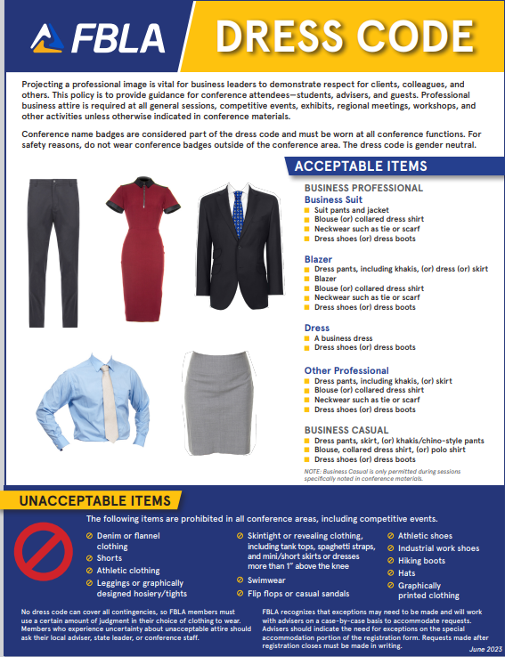

North Carolina Professional Division
The Professional Division supports and promotes FBLA, Inc. and its goals. Members:
- Support FBLA programs and serve as liaisons between the workplace and the classroom.
- Mentor FBLA members to strengthen leadership and provide career counseling.
- Keep members informed on current business trends.
- Established business professionals can help, teach, and encourage the rising generation of business leaders. Professional members give students the chance to work one-on-one with experienced leaders. Members receive the FBLA Professional Edge and other national publications. Anyone who has an interest in FBLA- can become a Professional Division member/former member, employers, educators, FBLA- advisers, parents, businesspeople, and community supporters.

North Carolina FBLA

Professional Division Membership Application

National FBLA is in the process of transitioning to an Alumni & Professional Network. There is no fee to belong to this network. If you are interested in joining the NC Professional Division, please complete this form and send via email to Shannon McConnell at ncfblaprodiv@gmail.com .

First Name | Middle |  |  | Last
Home Address |  | City |  |  | State | Zip
Home Email |  |  |  |  | Home Phone
School/Work Address |  | City |  |  | State | Zip
School/Work Email |  |  |  |  | School/Work Phone
High School Attended |  |  | Year of Graduation

I am willing to help with Regional Events. | YES | NO | Counties where I can help:
I am willing to administer workshops. | YES | NO | Topics I can speak on:
I am willing to help with State Leadership Conferences (located in Greensboro, NC). | YES | NO | Events I have worked with:
I am willing to attend and help with Southern Region Fall Leadership Conference | YES | NO
I am willing to attend and help with National Leadership Conferences. | YES | NO

